**Actors –** Thereis only one actor who will interact with the system.

**System –** There are specific actions and interaction between the user and system. The user will add the amount for playing the game in the Gaming Card.If amount will be less than 10, message would be displayed to user that – Minimum amount should be greater than 10. If he further wants to play then he has to add the amount greater than 10. If it is a weekday then Rs 10/ game else Rs. 20 per game.

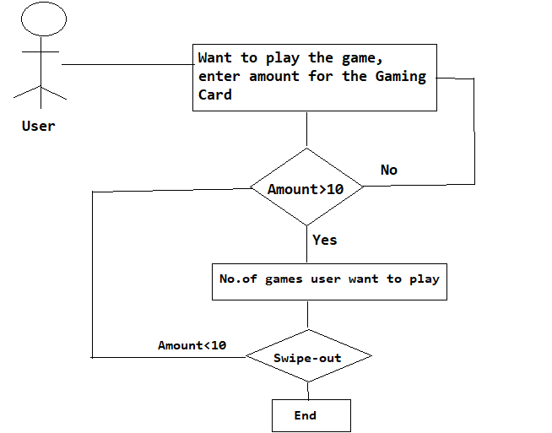

**Goals** **–** The end result is when the user swipe out but with the condition that the card should not have negative value.